**Ideation Phase**

**Define the Problem Statement**

|  |  |
| --- | --- |
| **Date** | 27 June 2025 |
| **Team ID** | LTVIP2025TMID20380 |
| **Project Name** | HouseHunt: Finding Your Perfect Rental Home |
| **Maximum Marks** | 2 Marks |

**Customer Problem Statement:**

In today’s competitive housing market, tenants often face significant challenges in finding suitable rental homes. They have to browse multiple real estate websites, deal with brokers, and face delays in communication and verification. The lack of a centralized, transparent, and user-friendly rental platform leads to frustration, wasted time, and often misleading information. Customers are looking for a reliable digital solution where they can find verified rental listings, contact owners directly, and book visits or deals seamlessly.

**Key Customer Pain Points:**

* Too many platforms with inconsistent or outdated rental listings
* No direct communication with property owners
* Hidden charges or unreliable brokers
* Limited access to verified property details, images, and reviews
* Time wasted visiting unsuitable houses without clear information

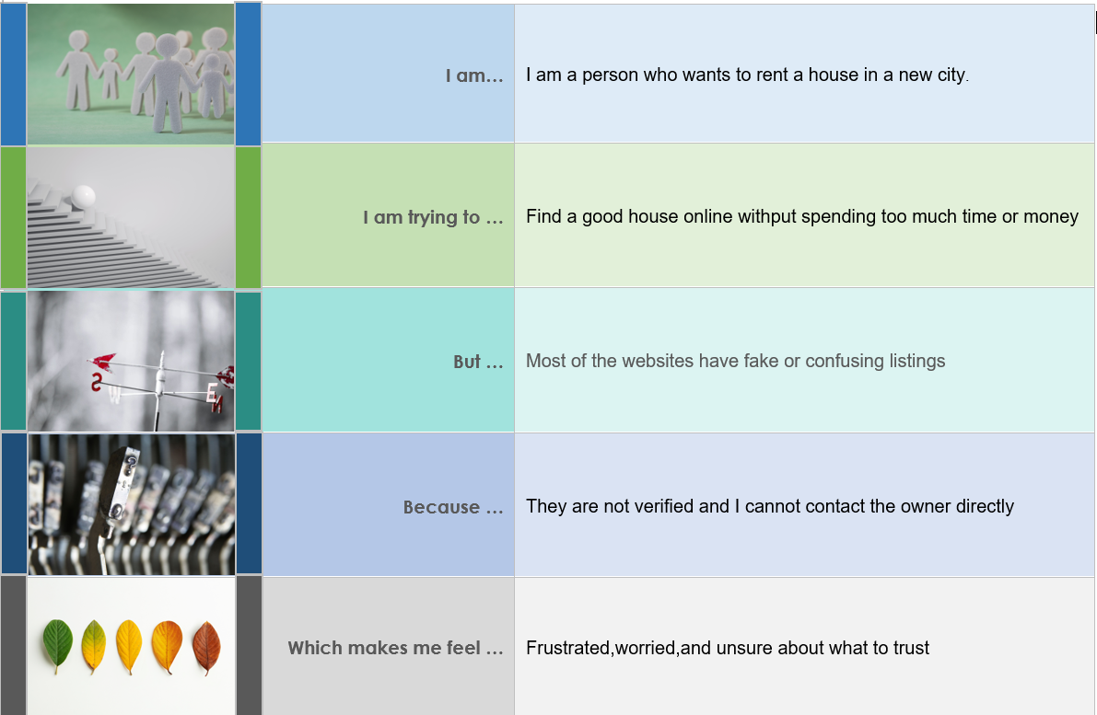

**Problem Statements (PS):**

|  |  |  |  |  |  |
| --- | --- | --- | --- | --- | --- |
| **Problem Statement** | **I am** | **I’m trying to** | **But** | **Because** | **Which makes me feel** |
| **PS-1** | a student/professional moving to a new city | find a suitable rental house quickly and reliably | there are too many scattered listings and unreliable brokers | most listings are not verified or up-to-date | stressed and uncertain about my relocation |
| **PS-2** | a property owner with vacant flats | list my property and find trustworthy tenants | existing platforms are complex or charge high commissions | I prefer a simple and direct way to reach renters | frustrated by the difficulty of filling vacancies |